Lab 9: Arrays

Lesson 12-2: One-Dimensional Array with Integer Indexes

Exercise 1:
// Program Reverse reads numbers into an array
// and prints them out in reverse order.

#include <iostream>
#include <fstream>
using namespace std;

const int MAX = 10;

int main ()
{
int numbers[MAX];
ifstream inData;
int value;
int index;

inData.open("reverse.dat");
for (index = 0; index < MAX; index++)
{
inData >> value;
numbers[index]= value;
}

for (index = MAX - 1; index >= 0; index--)
cout << numbers[index] << endl;

system("PAUSE");
return 0;
}
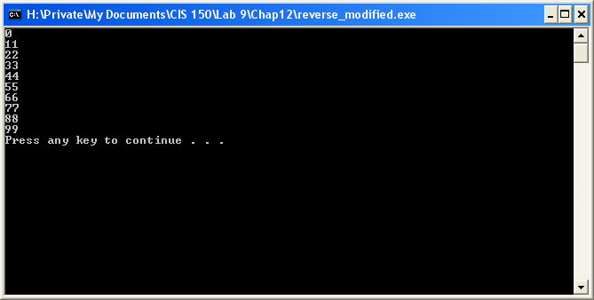

Exercise 2:
// Program Reverse reads numbers into an array
// and prints them out in reverse order.

#include <iostream>
#include <fstream>
using namespace std;

const int MAX = 10;

int main ()
{
int numbers[MAX];
ifstream inData;
int value;
int index;

inData.open("reverse.dat");
for (index = 0; index < MAX; index++)
{
inData >> numbers[index];
}

for (index = MAX - 1; index >= 0; index--)
cout << numbers[index] << endl;

system("PAUSE");
return 0;
}

Exercise 3:
// Program Reverse reads numbers into an array
// and prints them out in reverse order.

#include <iostream>
#include <fstream>
using namespace std;

const int MAX = 10;

int main ()
{
int numbers[MAX];
ifstream inData;
int value;
int index;

inData.open("reverse.dat");
for (index = 0; index < MAX; index++)
{
inData >> numbers[index];
value = value + numbers [index];
}

for (index = MAX - 1; index >= 0; index--)
cout << numbers[index] << endl;
cout << "The sum of the values stored in numbers is "
<< value << " ." << endl;

system("PAUSE");
return 0;
}
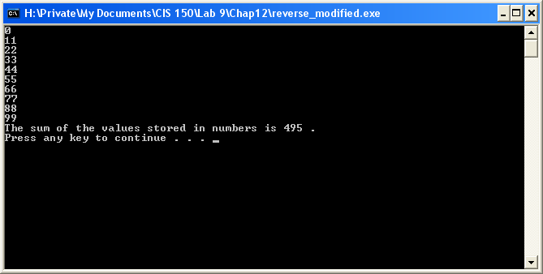

Lesson 12-6: Debugging

Exercise 1 & Exercise 2:

Modified:
// Program ReadData manipulates a two-dimensional table.

#include <iostream>
#include <fstream>
#include <iomanip>
using namespace std;

const int ROW_MAX = 8;
const int COL_MAX = 10;

typedef int ItemType;

typedef ItemType Table[ROW_MAX][COL_MAX];

int main ()
{
Table table;
int rowsUsed;
int colsUsed;
ifstream dataIn;
ofstream dataOut;

dataIn.open("debug.dat");
dataOut.open("debug.out");
dataIn >> rowsUsed >> colsUsed; ← colsUsed and rowsUsed were swapped
// Input table values.
for (int col = 0; col < colsUsed; col++)
for (int row = 0; row < rowsUsed; row++)
dataIn >> table[row][col];

// Output table values.
for (int row = 0; row < rowsUsed; row++) ←needed to add type declaration “int”
{
for (int col = 0; col < colsUsed; col++) ←needed to add type declaration “int”
dataOut << setw(3) << table[row] [col];
dataOut << endl;
}
system("PAUSE");
return 0;
}

The problem with the original coding is bolded.

Lesson 12-7: Case Study Maintenance

Exercise 3:
#include <iostream>

using namespace std;

const int MAX = 26;

int main ()
{
int CharCounter[MAX];
int index;

for (index = 0; index < MAX; index++)
{
CharCounter[index] = 0;
}

for (index = 0; index < MAX; index++)
cout << CharCounter [index] << endl;

system("PAUSE");
return 0;
}
